Faculty application. Installation of a field gate on Benefice land adjacent to St Michaels’ Church. Galleywood.

This application was initiated under the system used prior to the automated faculty application. A notification of advice was received under the previous system.

The application relates to the installation of a field gate on Benefice land. The gate will only be used for access by vehicles that might remove garden waste and logs, and is not for public use. St Michaels Church is a grade II listed building, but the gate will not be within the curtilage of the church and graveyard as it is separated by the allotment. The church and graveyard are hedged and separated from the allotments. The allotments are hedged and separated from the copse area. See diagram below.

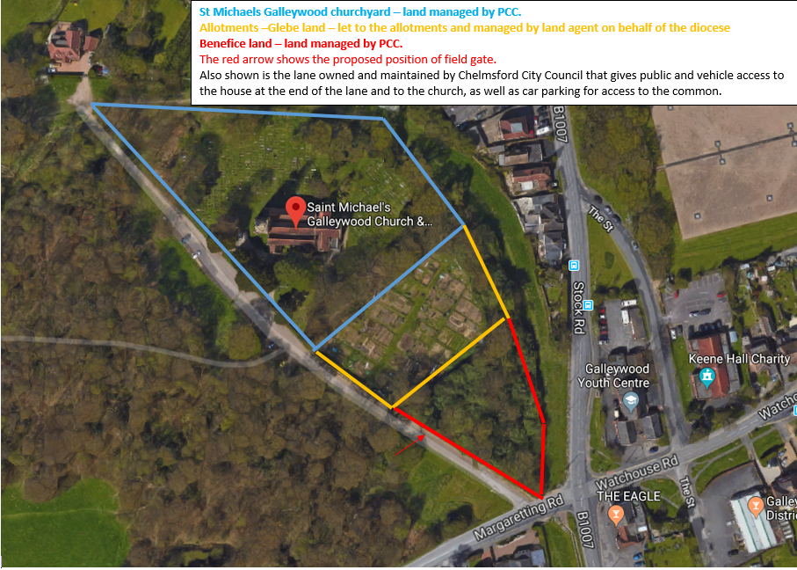

There has never been a public access to the copse area. The copse area has historically been hedged, but the hedges are somewhat degraded. We intend to use the copse area for games, picnics and such like. The gate will be on the copse boundary that is adjacent to the current Chelmsford city council road that gives access to a house at the end of the lane and the church. Thus the gate will be on an existing public right of way which will be used to get to the gate.

Note that the statement from the DAC recommendation from February 24, 2021
“The historic reference mentions that there was an access onto pubic highway but no reference how long ago it was last used? The parish to consult their Local Authority Highways department on whether there was originally an access from the land to the public highway and that the parish have authority to reopen with new access?”
Is not applicable because there has not been an access onto the public highway in the past. I apologise if my previous answer caused confusion about this point.

The parish have consulted with the Local Authority Highways department, who have advised in an email dated 9 February 2021 that
“You would not need planning permission for a gate but you would need permission from our property services section if it gives access onto CCC (Chelmsford City Council) land”.
So no planning permission is required because “so long as it does not give access to CCC land” – which it does not.

